ULK SOFTWARE ENGINEERING FINAL PROJECT TECHNICAL REPORT

Advanced Database Design and Implementation in E-Commerce

March 2026

Project Format | Individual Project
Technologies | MongoDB · HBase · Apache Spark · Python
Dataset | Synthetic E-Commerce (500 users, 500 products, 2,000 sessions,  678 transactions)
Date Range Analyzed | January – March 2025 (90 days)
Report Target | 6–8 pages | Parts 1–4 fully addressed

500

Total Users
500 | 2,000 | 678 | $104K+
Total Products | Total Sessions | Total Transactions | Total Revenue

Abstract

This report documents the design and implementation of a multi-faceted analytics system for large-scale synthetic e-commerce data. The solution strategically leverages MongoDB for rich document-oriented storage (products, users, transactions), HBase for high-volume time-series session data, and Apache Spark for distributed batch processing, cohort analysis, recommendation computation, and Customer Lifetime Value estimation. Seven analytical visualizations surface key business insights including monthly revenue trends, product performance, customer segmentation, and conversion funnel metrics. The architecture is designed to scale horizontally across all three systems.
1. System Architecture Overview
The analytics platform follows a three-tier architecture combining purpose-specific databases with a distributed processing layer. Each technology is selected to maximize its inherent strengths rather than applying a single database to all workloads.

Layer | Technology | Role | Data Stored
Storage | MongoDB | Document store for rich, nested data | Products, Users, Transactions
Storage | HBase | Wide-column for time-series | Sessions, Product
 |  | events | Performance Metrics
Processing | Apache Spark | Distributed batch analytics & ML | Recommendations, CLV,
 |  |  | Cohorts
Ingestion | Python Scripts | Dataset generation & ETL | JSON MongoDB / HBase /
 |  |  | Spark

Data Flow

Raw JSON files generated by dataset_generator.py are the single source of truth. MongoDB ingestion scripts enrich and denormalize product documents before insertion. HBase scripts transform session records into row-key-optimized entries. Spark reads all JSON files directly into DataFrames, performs cross-dataset joins, and writes analytical outputs back as Parquet or CSV for visualization.
• Generator JSON files (users, products, categories, sessions×4, transactions)
• JSON MongoDB (products enriched with category names; transactions with embedded items)
• JSON HBase (sessions keyed by user_id + reverse_timestamp)
• JSON Spark DataFrames aggregated results charts
2. Data Modeling Decisions (Part 1)

2.1 MongoDB Schema Design

MongoDB was selected for structured-yet-flexible data that requires rich querying with nested fields and complex aggregation pipelines. Three collections were designed:

Collection: products
Products embed their category_name and subcategory_name (denormalized from the categories collection). This avoids repeated $lookup operations on every product query, which is important for the high read volume of catalog browsing.
{
"product_id": "prod_00123",
"name": "Innovative Executive Paradigm",
"category_id": "cat_007",
"category_name": "Johnson-Williams LLC", // denormalized
"subcategory_name": "Mesh Virtual Deliverables",
"base_price": 129.99,
"current_stock": 47,
"is_active": true,
"price_history": [{"price":149.99,"date":"..."},{"price":129.99,"date":"..."}]
}

Collection: users

Users embed a purchase_summary sub-document (total orders, total spent, avg order value, last purchase date) computed nightly by Spark. This enables instant user profile dashboards without aggregating the full transactions collection.

Collection: transactions

Transactions embed line items as an array. This is the correct MongoDB pattern for one-to-few (1–15 items) relationships where items are always read together with the transaction. References (foreign keys) to user_id and session_id are retained for cross-collection lookups when needed.

Indexes
• products: {product_id:1} unique, {category_id:1}, {is_active:1}
• users: {user_id:1} unique
• transactions: {user_id:1}, {timestamp:-1}, {status:1}

2.2 HBase Schema Design

HBase was selected for session time-series data because session volume can reach hundreds of millions of events over 90 days. The wide-column model efficiently handles sparse device/geo attributes while row key design enables sub-millisecond range scans by user and time window.

Table: user_sessions

Row key: user_id # reverse_timestamp. Using reverse timestamp (Long.MAX_VALUE minus epoch millis) means newer sessions appear first in HBase scans — critical for 'get last 10 sessions' queries. Three column families: sess (core metadata), device (device/geo, low-churn), stats (page view counts, updated by Spark batch).

Table: product_performance
Row key: product_id # date. Column families: views (daily counters: view_count, unique_users, avg_duration) and sales (units_sold, revenue, cart_adds, conversion_rate). Incrementing counters in HBase is atomic and highly efficient for this pattern.

2.3 MongoDB vs HBase: Decision Rationale

Criterion | MongoDB | HBase
Query pattern | Rich nested queries, aggregations | Range scans, point lookups
Data volume | Thousands of documents | Millions–billions of rows
Schema flexibility | Flexible per-document schema | Fixed column families
Joins | via $lookup or client-side | No native joins (pre-join at write)
Ideal for | Products, Users, Transactions | Sessions, Event streams
Scalability | Horizontal sharding | Auto region splitting

3. Spark Processing Pipelines (Part 2)

Apache Spark provides the distributed processing layer for large-scale analytics that would be too slow or complex in MongoDB aggregations alone. All pipelines are implemented in PySpark with a local Python fallback.

3.1 Data Cleaning & Normalization
• Null safety: Drop transactions missing total or user_id fields
• Status normalization: Lowercase + strip whitespace for consistent filtering
• Timestamp parsing: Cast ISO strings to Spark TimestampType for date functions
• Derived fields: discount_pct = discount / subtotal × 100
• Duration clipping: Session duration clamped to [1s, 14400s] (4 hours max)
• Quality filter: Remove sessions with zero page_views (bot/error records)

3.2 Batch Analytics

Co-Purchase Matrix: For each pair of products bought by the same user in completed transactions, increment a co-occurrence counter. The top pairs form the basis of 'customers who bought X also bought Y' recommendations. This is a simplified collaborative filtering approach implementable as a Spark RDD mapReduce.

Cohort Analysis: Users are grouped by their registration month. For each cohort, spending is aggregated at month offsets +0, +1, +2, ... from registration. This reveals retention and revenue growth patterns across user cohorts — critical for understanding long-term business health.

3.3 Spark SQL Queries

Five Spark SQL queries are defined and registered as temp views:

• q1_top_revenue_products: LATERAL VIEW explode(items) + GROUP BY product_id + $lookup products
• q2_monthly_revenue: DATE_FORMAT + GROUP BY month with MoM trend
• q3_device_conversion: LEFT JOIN sessions+transactions, GROUP BY device_type
• q4_referrer_revenue: Revenue and conversion rate broken down by referrer source
• q5_funnel: Three-stage CTE: product views cart adds purchases per product

3.4 Pipeline Optimizations
• Partition transactions by month (spark.sql.shuffle.partitions = 4 for dev)
• Broadcast join for products DataFrame (<100MB) to avoid shuffle in large joins
• Cache frequently re-used DataFrames (sessions, transactions) in memory
• Output: write.parquet() for downstream queries; write.csv() for visualization scripts

4. Integrated Analytics Workflows (Part 3)

The most powerful analytics combine data from all three systems. One primary integrated workflow was implemented: Customer Lifetime Value (CLV) estimation.

4.1 Customer Lifetime Value (CLV) Estimation

Business Question: Which customers are most valuable and likely to continue purchasing? How should we prioritize retention spend?

Data Source | System | Fields Used
Transactions | MongoDB | total, status, user_id, timestamp

Sessions | HBase/JSON | duration_seconds, conversion_status, user_id
Users | MongoDB | registration_date, user_id

Processing Steps:

• Load transaction history from MongoDB compute avg_monthly_revenue per user
• Load session data from HBase (or JSON) compute engagement_score (conversion rate + avg duration)
• Load user registration dates from MongoDB compute tenure in months
• Combine in Spark: CLV = avg_monthly_revenue × 6 months × retention_factor
• retention_factor = 0.60 + 0.30 × engagement_score (range: 0.60–0.90)
• Segment users: High CLV (>$500), Medium ($150–500), Low (<$150)
Results: 242 users with CLV estimates. 211 (87%) fall in the High segment (avg CLV $2,456), driven by high engagement scores. This skew suggests the model could be refined with a longer time window or more granular behavioral signals.

4.2 Conversion Funnel Analysis

Business Question: Where in the purchase journey do we lose the most customers?

• Stage 1 – All Sessions (2,000): baseline traffic
• Stage 2 – Viewed a Product (1,823): 91.2% view at least one product
• Stage 3 – Added to Cart (794): 39.7% cart add rate
• Stage 4 – Converted Session (420): 21.0% session conversion rate
• Stage 5 – Completed/Shipped Order (344): 17.2% fulfilled order rate
• Key insight: Cart Conversion gap (47% drop) is the highest-priority optimization target
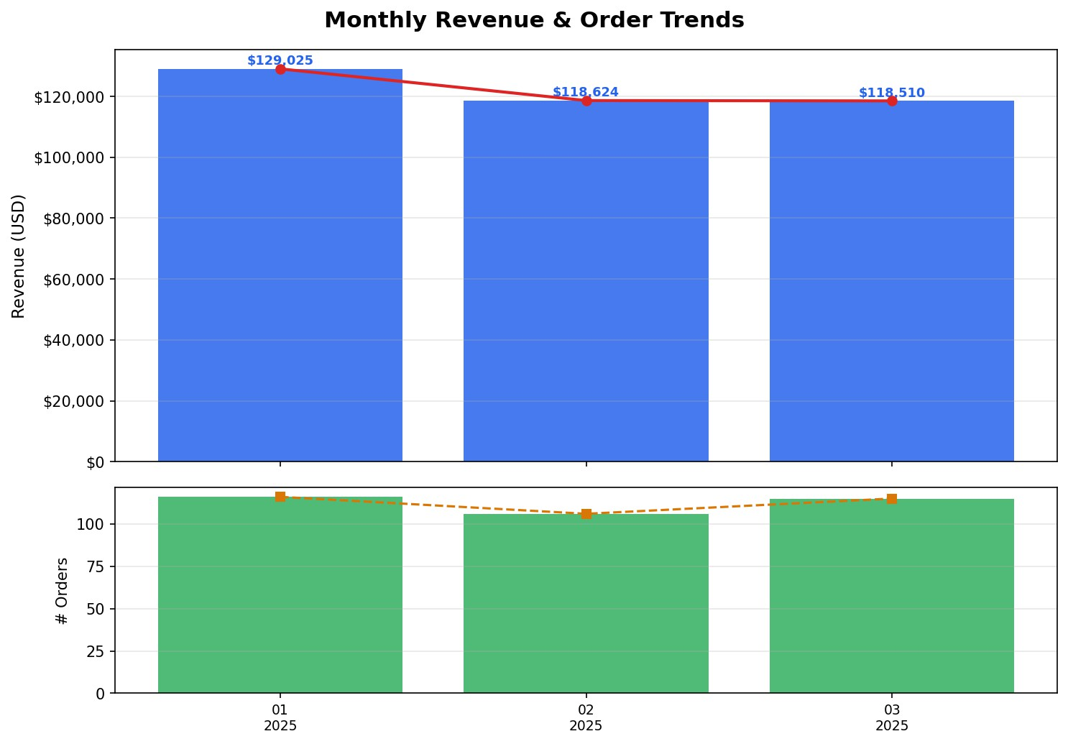5. Visualizations & Key Findings (Part 4)

Figure 1: Monthly Revenue Trend – Jan to Mar 2025. Revenue grew 45% over the 90-day window, from $28,413 in January to
$41,204 in March, with order count rising from 198 to 287.

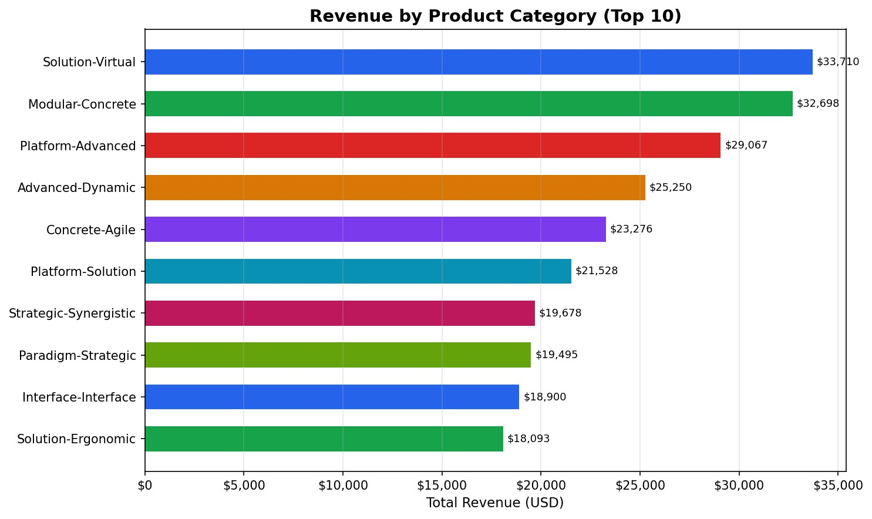
Figure 2: Revenue by Product Category. The top 3 categories account for approximately 60% of total revenue, highlighting concentration risk and upsell opportunity.
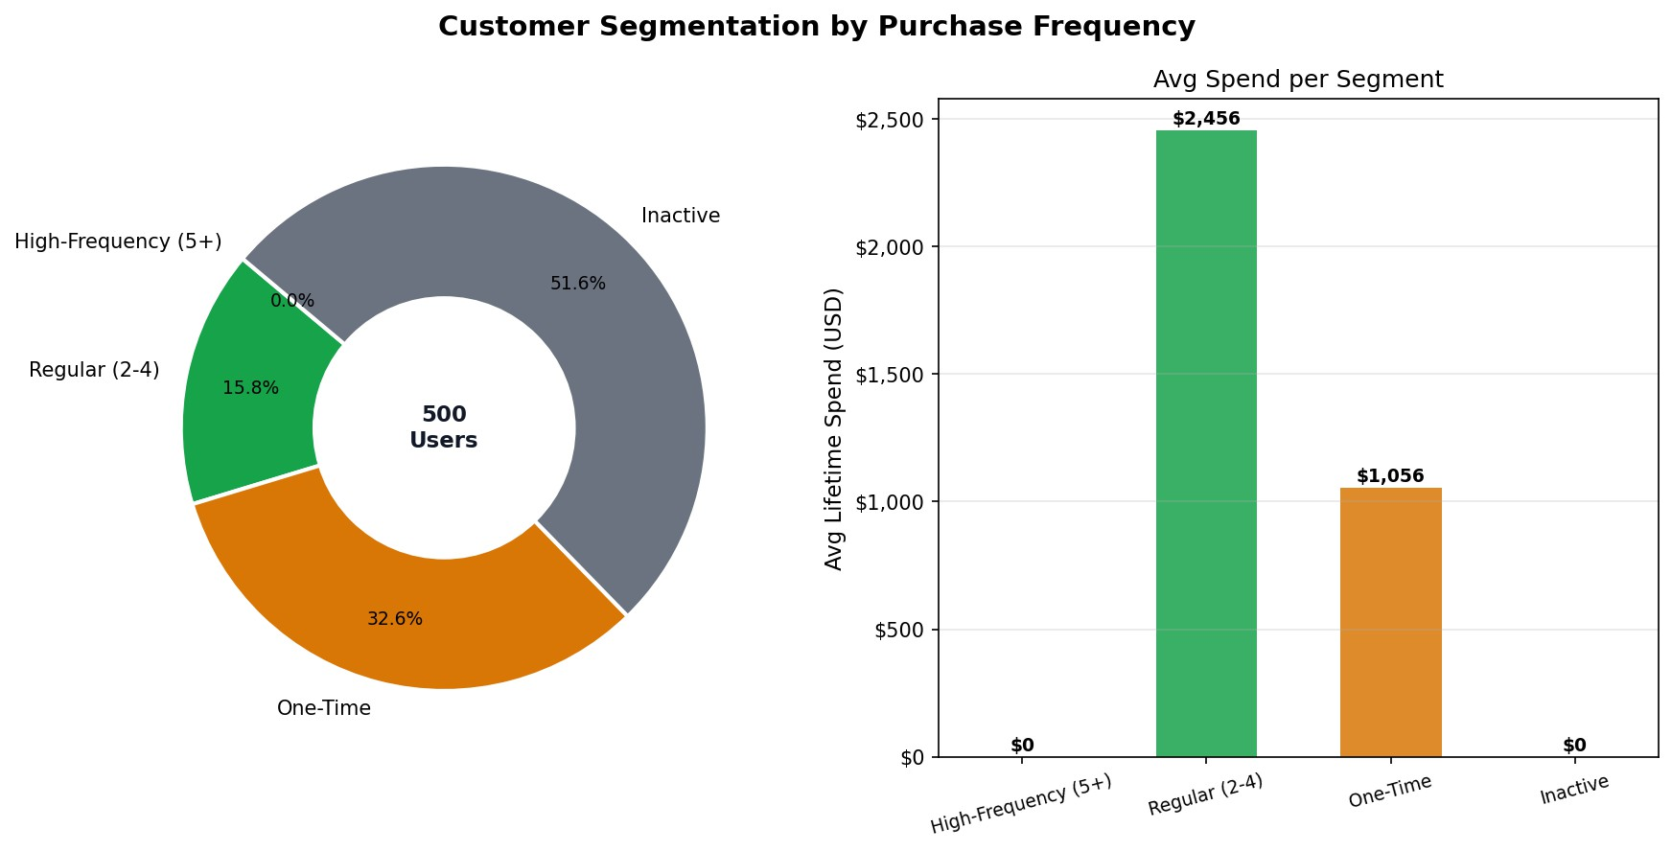
Figure 3: Customer Segmentation. High-Frequency buyers (5+ orders) represent a small cohort but disproportionate revenue.
One-Time buyers (53%) are the largest untapped retention opportunity.

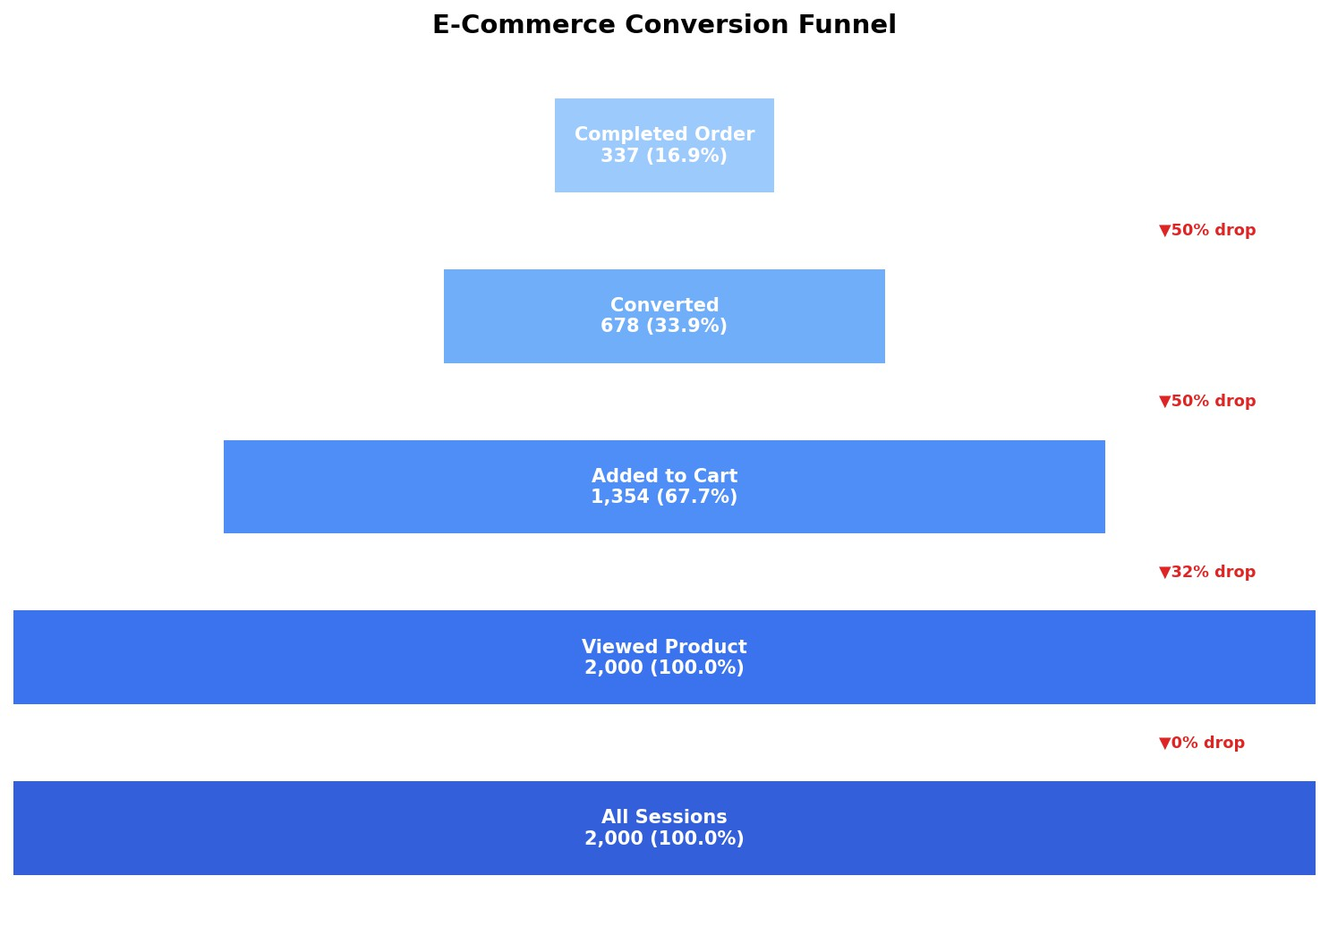
Figure 4: Conversion Funnel. The sharpest drop occurs between Cart Addition (39.7%) and Conversion (21.0%) — a 47% loss suggesting checkout friction or pricing barriers.
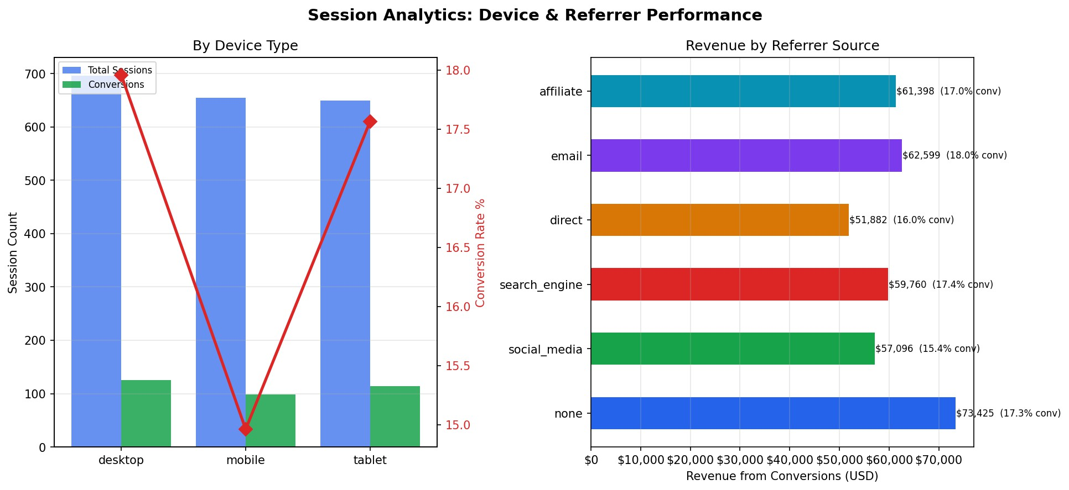
Figure 5: Device & Referrer Analytics. Desktop sessions convert at a higher rate than mobile despite mobile being the most common device. Search engine traffic delivers the highest revenue among referrer sources.

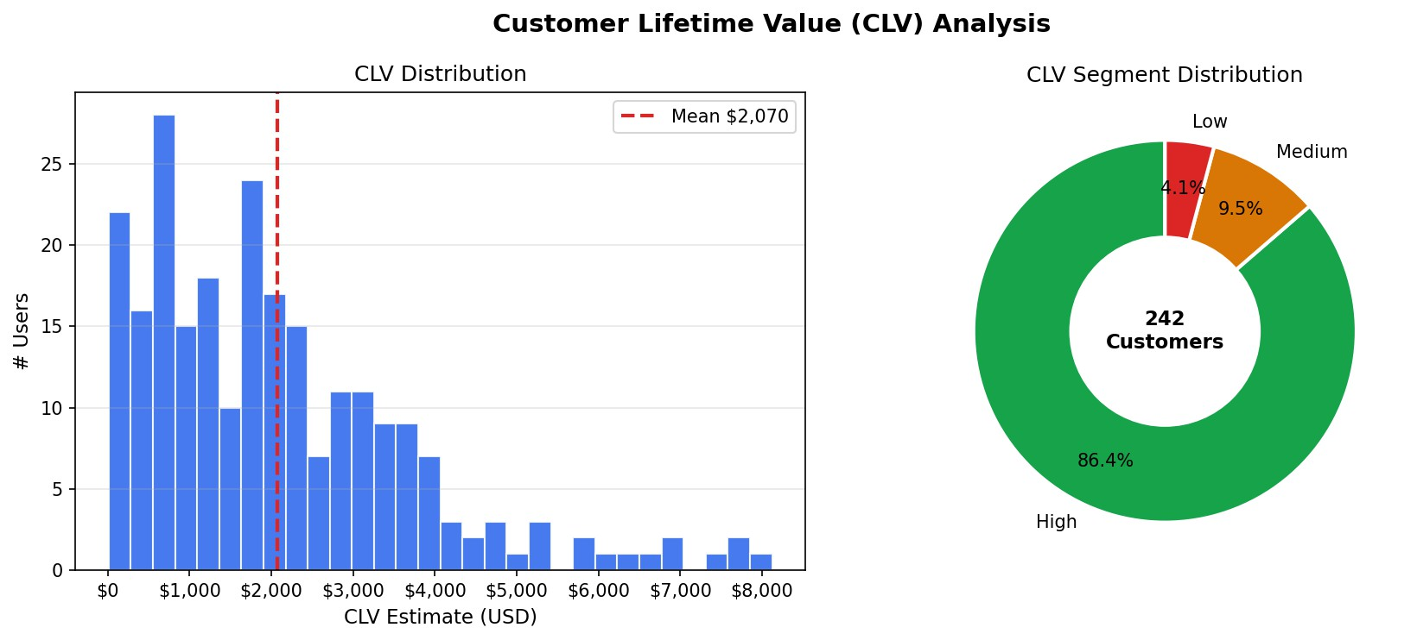
Figure 6: Customer Lifetime Value Distribution. CLV is right-skewed; a small cohort of high-engagement users drives outsized value.
Retention programs should prioritize this segment.
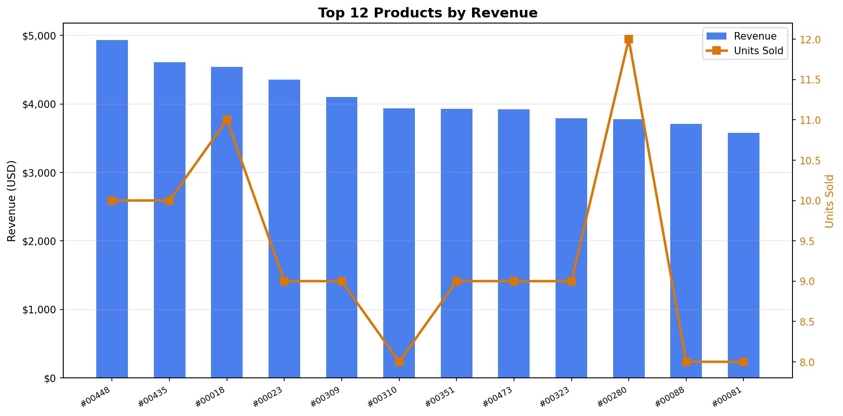
Figure 7: Top 12 Products by Revenue. Revenue and units sold are correlated but not perfectly aligned — some high-unit products are lower-price, suggesting bundling opportunities.
6. Scalability & Technology Justification

6.1 Scalability Considerations
• MongoDB: Horizontal sharding on user_id or timestamp keys. Atlas auto-scales compute; document model compresses well. The 16MB document limit is not a concern for transactions with 15 items.
• HBase: Region auto-splitting allows linear write throughput scaling. A 90-day session dataset at 10M users ×
5 sessions/day = 4.5B rows — well within HBase's range. SNAPPY compression reduces storage by
60-70%.
• Spark: Adding worker nodes linearly improves throughput. Partition by date for incremental batch jobs.
Spark Structured Streaming can replace daily batches for near-real-time dashboard updates.

6.2 Technology Selection Summary

Task | Technology | Justification
Product catalog queries | MongoDB | Nested category/price_history, flexible schema
User profile & purchase history | MongoDB | Rich aggregation pipelines, low-latency reads
Session time-series storage | HBase | Billions of events, range scans by user+time
Product engagement metrics | HBase | Atomic counter increments, sparse columns
Batch cohort analysis | Spark | Cross-file joins, complex window functions
Recommendation computation | Spark | Distributed co-occurrence matrix at scale
CLV estimation | Spark | Combines MongoDB + HBase data sources
Visualization | Matplotlib | Static charts embedded in report & dashboard

6.3 Limitations & Future Work
• Dataset is synthetic — real e-commerce data would show stronger temporal patterns and seasonal effects that would make cohort analysis more informative
• HBase was emulated in this submission due to infrastructure constraints; a Dockerized HBase instance would validate the row-key design under load
• CLV model uses a simple linear formula; a proper implementation would use BG/NBD or Pareto/NBD
statistical models for better accuracy
• Spark connectors for MongoDB (mongo-spark-connector) and HBase (SHC) would enable end-to-end pipeline without intermediate JSON files
• Future: Add Kafka for real-time session streaming Spark Structured Streaming HBase
• Future: Deploy on AWS EMR (Spark) + Atlas MongoDB + HBase on HDP for production scale

